Standard Operating Procedure

 | Process Name: DAILY OPERATIONS |  | Author: SUPRATIK DAS ROY
 |  |  | Reviewer:
 | Ver : 1.0 | Effective Date: 01/05/17 | Approver:

The content of this document is intended for IBM internal use only. None of this information shall be divulged to persons other than IBM employees, or individuals or organizations authorized by IBM in accordance with existing policy regarding release of company information.

Table of Contents
Table of Contents 2
1. Document Control 3
1.1. Document Statistics 3
1.2. Version History 3
1.3. Document Signoff 4
2. Overview 4
3. Architecture Diagrams 4
3.1. Process Architecture 4
3.2. Physical Architecture 4
4. SOP 4
4.1. Restart application (example) 4
4.2. Clear backlog. 4
5. Appendix & Glossary of Terms 4

Document Control

Document Statistics
Title | Procedure document for Operations
Version: | 1.0
Type: | Issue |  | X |  |  |  | Final |  |  | ✓
Filename: | Process- Daily Operational Activities
Reference file/Docs
Document Author(S ) | Supratik Das Roy
Document Owner(S )
Document Change Reviewers
  Application Owner | Prasun Pal
  Portfolio | Shobhit Tingal
  Peer Reviewer
Supporting Attributes: | Sensitivity: | Confidential |  |  | ✓ | Internal |  | X | Public |  | X
 | Language: | English (US)

- .1.1.Document Distribution
The official version of this document is located on the <Team Room>. Printed copies are for reference only and are not controlled. It is the responsibility of users of this document to ensure they are using the most recent version.

Version History
Date | Version No. | Editor | Summary of changes
01/05/17 | 1.0 | SUPRATIK DAS ROY | STANDARDIZATION

Document Signoff
Version No. | Review Date | Reviewer Name | Approval Dare | Approver Name
DD/MM/YY

Overview
AFFIRM identifies, corrects and prevents revenue leakage across the entire revenue chain of a telecom operator - from initial order to final settlement with customers and partners and allows operators to monitor the integrity of their assurance cycle. Since every operator has unique business processes and operational issues, the solution has been built on a modular, open framework based architecture allowing for great flexibility and scalability. This, coupled with deployment methodology and best practices has helped many customers achieve dramatic results in short periods. There are daily operational practices that needs to be executed on daily basis to ensure proper running of the application.
Schema Name | Functionality
ORV5_ETL | Used for storing FCT , DIM and RAW table data
ORV5_SYS, ORV_SYS1 | Used for storing system configuration information and status table data

Architecture Diagrams

Process Architecture

Physical Architecture

SOP

Server Credentials

ETL Server IP : 10.56.96.33
User ID : raorvner
PWD : *****
ETL Server IP : 10.56.96.28
User ID : raorv
PWD : *****
Source Location : /shared_data_mdg/ftpdata/
Poller Location : /poller_data_mdg/
ETL Server Details:
Application Location :
base location: /orvappl_mdg/CTVA/IRMS_DB2/connectiva-base/bin
etl location : /orvappl_mdg/CTVA/IRMS_DB2/connectiva-etl/bin

RAS Server IP : 10.56.96.34
User ID : raorvner
PWD : *****
RAS Application location:
RAS location : /orvappl_mdg/CTVA/IRMS_DB2/connectiva-ras/bin

DB Server IP : 10.56.96.31
User : ORV5_ETL, ORV5_SYS, ORV5SYS
Password : *****
SID : radb

Source Wise Details

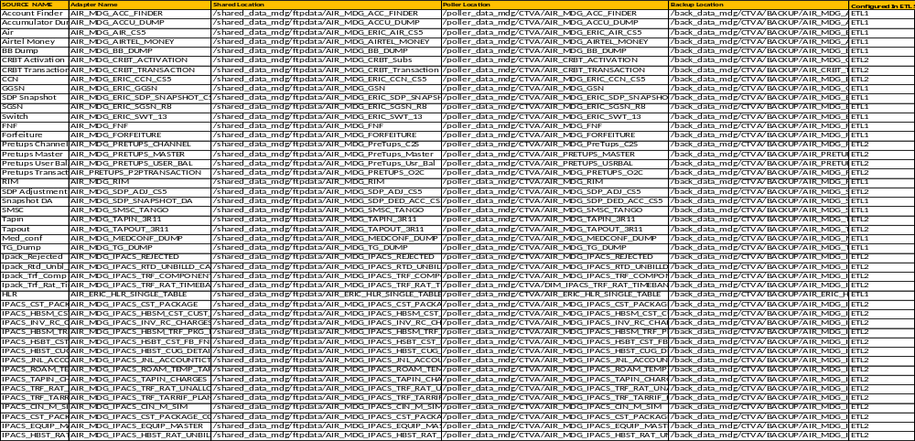

4.3. Crontab
Cron is the time-based job scheduler in Unix-like computer operating systems. cron enables users to schedule jobs (commands or shell scripts) to run periodically at certain times or dates. It is commonly used to automate system maintenance or administration, though its general-purpose nature means that it can be used for other purposes, such as connecting to the Internet and downloading email.

The Crontab for Madagascar RA_MLA as on March 3rd 2016.

10.56.96.28 Server CRON Tab entry:

##5,15,35,45 * * * * sh /orvappl_mdg/CTVA/FEED/bin/run_feed.sh feed_AIR_MDG_TAPIN_3R11 > /dev/null 2>&1
##8,18,38,58 * * * * sh /orvappl_mdg/CTVA/FEED/bin/run_feed.sh feed_AIR_MDG_TAPOUT_3R11 > /dev/null 2>&1
##2,12,35 * * * * sh /orvappl_mdg/CTVA/FEED/bin/run_feed.sh feed_AIR_MDG_ERIC_CCN_CS5 > /dev/null 2>&1
##7,17,37 * * * * sh /orvappl_mdg/CTVA/FEED/bin/run_feed.sh feed_AIR_MDG_SDP_ADJ_CS5 > /dev/null 2>&1
3,14,23,33,52 * * * * sh /orvappl_mdg/CTVA/FEED/bin/run_feed.sh feed_AIR_MDG_ERIC_AIR_CS5 > /dev/null 2>&1
4 * * * * sh /orvappl_mdg/CTVA/FEED/bin/run_feed.sh feed_AIR_MDG_SDP_DED_ACC_CS5 > /dev/null 2>&1
5,18,48,58 * * * * sh /orvappl_mdg/CTVA/FEED/bin/run_feed.sh feed_AIR_MDG_ERIC_SGSN_R8 > /dev/null 2>&1
6,21,39,46,57 * * * * sh /orvappl_mdg/CTVA/FEED/bin/run_feed.sh feed_AIR_MDG_GSN > /dev/null 2>&1
8,28,33,41,55 * * * * sh /orvappl_mdg/CTVA/FEED/bin/run_feed.sh feed_AIR_MDG_ERIC_SWT_13 > /dev/null 2>&1
13 * * * * sh /orvappl_mdg/CTVA/FEED/bin/run_feed.sh feed_AIR_MDG_ERIC_SDP_SNAPSHOT_CS5 > /dev/null 2>&1
1,12,29,40,51 * * * * sh /orvappl_mdg/CTVA/FEED/bin/run_feed.sh feed_AIR_MDG_SMSC_TANGO > /dev/null 2>&1
16 * * * * sh /orvappl_mdg/CTVA/FEED/bin/run_feed.sh feed_AIR_MDG_ACCU_DUMP > /dev/null 2>&1
32 * * * * sh /orvappl_mdg/CTVA/FEED/bin/run_feed.sh feed_AIR_MDG_BB_DUMP > /dev/null 2>&1
9,38 * * * * sh /orvappl_mdg/CTVA/FEED/bin/run_feed.sh feed_AIR_MDG_FNF > /dev/null 2>&1
1 * * * * sh /orvappl_mdg/CTVA/FEED/bin/run_feed.sh feed_AIR_MDG_FORFEITURE > /dev/null 2>&1
5 1,4,7,10,13,16,19,22 * * * sh /orvappl_mdg/CTVA/FEED/bin/run_feed.sh feed_AIR_ERIC_HLR_SINGLE_TABLE > /dev/null 2>&1
35 12 * * * /misc_mdg/CTVA/Auto_KPI/create_dir.sh >> /orvappl_mdg/CTVA/OperationScripts/LOG/create_dir_`date +\%Y\%m\%d_\%H\%M\%S`.log 2>&1
5,15,25,35,45,55 4,5,6,7,8,9,10 * * * /misc_mdg/CTVA/Auto_KPI/automate_kpi.sh >> /orvappl_mdg/CTVA/OperationScripts/LOG/automate_kpi_`date +\%Y\%m\%d_\%H\%M\%S`.log 2>&1
5 22 * * * /orvappl_mdg/CTVA/OperationScripts/Shared_Purging.sh >> /orvappl_mdg/CTVA/OperationScripts/LOG/Shared_Purging_`date +\%Y\%m\%d_\%H\%M\%S`.log 2>&1
20 23 * * * /orvappl_mdg/CTVA/OperationScripts/cleanup_script_daily.sh >> /orvappl_mdg/CTVA/OperationScripts/LOG/cleanup_script_daily_`date +\%Y\%m\%d_\%H\%M\%S`.log 2>&1
5 21 * * * /orvappl_mdg/CTVA/OperationScripts/stat_table_cleanup.sh >> /orvappl_mdg/CTVA/OperationScripts/LOG/Stat_Table_`date +\%Y\%m\%d_\%H\%M\%S`.log 2>&1
30 23 * * * /orvappl_mdg/CTVA/OperationScripts/err_table_delete_etl.sh >> /orvappl_mdg/CTVA/OperationScripts/LOG/Err_Table_`date +\%Y\%m\%d_\%H\%M\%S`.log 2>&1
30 3,7,11,15,19,23 * * * /orvappl_mdg/CTVA/iCTVA_Scripts/Ingest_Reload_File.sh >> /orvappl_mdg/CTVA/OperationScripts/LOG/Ingest_Reload_`date +\%Y\%m\%d_\%H\%M\%S`.log 2>&1
5 3 * * * /orvappl_mdg/CTVA/AdapterProc/populatePretupsUserBal.sh >> /orvappl_mdg/CTVA/OperationScripts/LOG/populatePretupsUserBal_`date +\%Y\%m\%d_\%H\%M\%S`.log 2>&1

10.56.96.33 Server CRON Entry:

2,17,32,47,56 * * * * sh /orvappl_mdg/CTVA/FEED/bin/run_feed.sh feed_AIR_MDG_ERIC_CCN_CS5 > /dev/null 2>&1
7,24,39,52 * * * * sh /orvappl_mdg/CTVA/FEED/bin/run_feed.sh feed_AIR_MDG_SDP_ADJ_CS5 > /dev/null 2>&1
5,22,38,51 * * * * sh /orvappl_mdg/CTVA/FEED/bin/run_feed.sh feed_AIR_MDG_PreTups_C2S > /dev/null 2>&1
8,26,42,59 * * * * sh /orvappl_mdg/CTVA/FEED/bin/run_feed.sh feed_AIR_MDG_PreTups_Master > /dev/null 2>&1
9,33,49,54 * * * * sh /orvappl_mdg/CTVA/FEED/bin/run_feed.sh feed_AIR_MDG_PreTups_O2C > /dev/null 2>&1
4,27,43,58 * * * * sh /orvappl_mdg/CTVA/FEED/bin/run_feed.sh feed_AIR_MDG_PreTups_Usr_Bal > /dev/null 2>&1
13,29,41,57 * * * * sh /orvappl_mdg/CTVA/FEED/bin/run_feed.sh feed_AIR_MDG_TAPIN_3R11 > /dev/null 2>&1
2,19,30,43,55 * * * * sh /orvappl_mdg/CTVA/FEED/bin/run_feed.sh feed_AIR_MDG_TAPOUT_3R11 > /dev/null 2>&1
13 * * * * sh /orvappl_mdg/CTVA/FEED/bin/run_feed.sh feed_AIR_MDG_IPACS_TRF_COMPONENTS > /dev/null 2>&1
16 * * * * sh /orvappl_mdg/CTVA/FEED/bin/run_feed.sh feed_AIR_MDG_HBST_RAT_UNBILD_CALL > /dev/null 2>&1
25 * * * * sh /orvappl_mdg/CTVA/FEED/bin/run_feed.sh feed_AIR_MDG_IPACS_TRF_RAT_TIMEBAND > /dev/null 2>&1
3 * * * * sh /orvappl_mdg/CTVA/FEED/bin/run_feed.sh feed_AIR_MDG_IPACS_REJECTED > /dev/null 2>&1
#18 * * * * sh /orvappl_mdg/CTVA/FEED/bin/run_feed.sh feed_AIR_MDG_INV_RC_CHARGES > /dev/null 2>&1
#23 * * * * sh /orvappl_mdg/CTVA/FEED/bin/run_feed.sh feed_AIR_MDG_CST_PACKAGE_COMPONENTS > /dev/null 2>&1
#33 * * * * sh /orvappl_mdg/CTVA/FEED/bin/run_feed.sh feed_AIR_MDG_CST_PACKAGES > /dev/null 2>&1
#42 * * * * sh /orvappl_mdg/CTVA/FEED/bin/run_feed.sh feed_AIR_MDG_TRF_TARIFF_PLAN > /dev/null 2>&1
#49 * * * * sh /orvappl_mdg/CTVA/FEED/bin/run_feed.sh feed_AIR_MDG_HBSM_CST_CUST_MAST > /dev/null 2>&1
#57 * * * * sh /orvappl_mdg/CTVA/FEED/bin/run_feed.sh feed_AIR_MDG_EQUIP_SUBSCRIPTION_MASTER > /dev/null 2>&1
#4 * * * * sh /orvappl_mdg/CTVA/FEED/bin/run_feed.sh feed_AIR_MDG_HBSM_TRF_PKG_MAST > /dev/null 2>&1
30 02 * * * /orvappl_mdg/CTVA/OperationScripts/stat_table_cleanup.sh >> /orvappl_mdg/CTVA/OperationScripts/LOG/Stat_Table_`date +\%Y\%m\%d_\%H\%M\%S`.log 2>&1
53 1,5,9,13,17,21 * * * /orvappl_mdg/CTVA/iCTVA_Scripts/Ingest_Reload_File.sh >> /orvappl_mdg/CTVA/OperationScripts/LOG/Ingest_Reload_`date +\%Y\%m\%d_\%H\%M\%S`.log 2>&1
20 23 * * * /orvappl_mdg/CTVA/OperationScripts/cleanup_script_daily.sh >> /orvappl_mdg/CTVA/OperationScripts/LOG/cleanup_script_daily_`date +\%Y\%m\%d_\%H\%M\%S`.log 2>&1
5 23 * * * /orvappl_mdg/CTVA/OperationScripts/Shared_Purging.sh >> /orvappl_mdg/CTVA/OperationScripts/LOG/Shared_Purging_`date +\%Y\%m\%d_\%H\%M\%S`.log 2>&1

4.4. Daily Jobs
Mount Point check: (2-3 times daily for etl and ras server)
df -h [alarm: 85%]
SERVER IP: 10.56.96.28
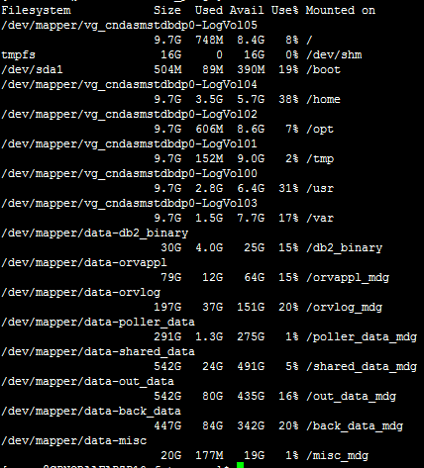

SERVER IP: 10.56.96.33
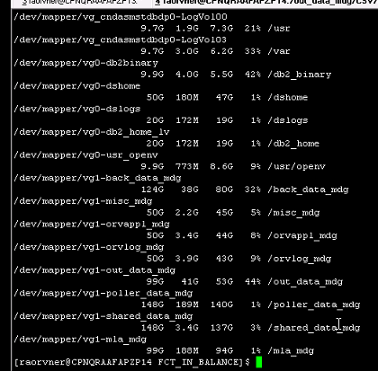

DB SERVER: 10.56.96.31
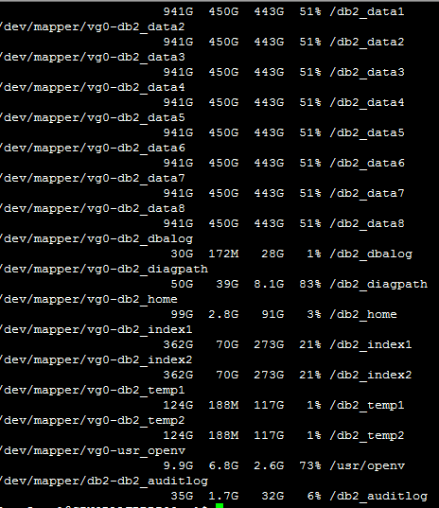

Check the servers (ETL n RAS)(minimum 4 times daily for each servers):
cd <server location>
tail –f nohup.out
Need to check and tally the date and time of last instance with current date-time. If server(s) is/are not running then need to start the server or report the same to senior.
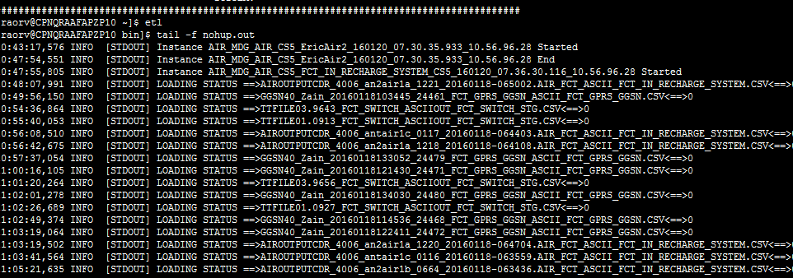

KPI Reports:
KPIs to be checked
TABLE NAME : ORV5_ETL.MLA_REPORT_META_DATA
RAS -SERVER IP: 10.56.96.34
Path: /misc_niger/MDG_KPI

Reports
The reports are part of Daily Job.
- FCT_CDR_COUNT_TREND_REPORT:

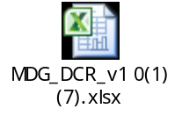
DCR Report:
1. DCR script path: /orvappl_mdg/CTVA/OperationScripts
2. run ./dcrReport.sh for DCR REPORT
LOGS

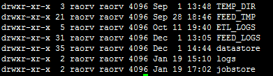

All Duplicate logs
command | cd /out_data_mdg/CSV/duplicate/<Adapter Name>/

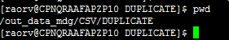

All Error Logs
command | cd /out_data_mdg/CSV/error/<Adapter Name>/

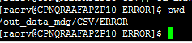

All Ingest Cleanup log
command | more /orvappl_mdg/CTVA/OperationScripts/cleanup_script_daily.sh

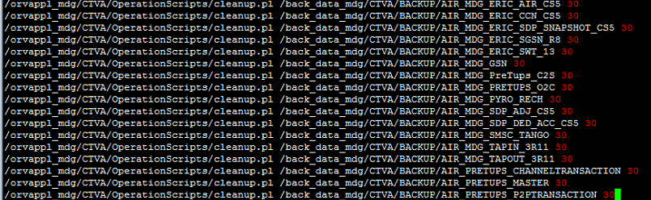

Additional information: ADAPTER SUPPORT ORGANISATION:
Data Sources Applicable | support
AIR_MDG_ACC_FINDER | ictva
AIR_MDG_ACCU_DUMP | ictva
AIR_MDG_AIR_CS5 | ictva
AIR_MDG_AIRTEL_MONEY | ictva
AIR_MDG_CRBT_ACTIVATION | ictva
AIR_MDG_CRBT_TRANSACTION | ictva
AIR_MDG_ERIC_CCN_CS5 | ictva
AIR_MDG_ERIC_GGSN | ictva
AIR_MDG_ERIC_SDP_SNAPSHOT_CS5 | ictva
AIR_MDG_ERIC_SGSN_R8 | ictva
AIR_MDG_ERIC_SWT_13 | ictva
AIR_MDG_FNF | ictva
AIR_MDG_FORFEITURE | ictva
AIR_MDG_PRETUPS_CHANNEL | ictva
AIR_MDG_PRETUPS_MASTER | ictva
AIR_MDG_PRETUPS_USER_BAL | ictva
AIR_PRETUPS_P2PTRANSACTION | ictva
AIR_MDG_RIM | ictva
AIR_MDG_SDP_ADJ_CS5 | ictva
AIR_MDG_SDP_SNAPSHOT_DA | ictva
AIR_MDG_SMSC_TANGO | ictva
AIR_MDG_TAPIN_3R11 | ictva
AIR_MDG_TAPOUT_3R11 | ictva
AIR_MDG_MEDCONF_DUMP | ictva
AIR_MDG_TG_DUMP | ictva
AIR_MDG_IPACS_REJECTED | ictva
AIR_MDG_IPACS_RTD_UNBILLD_CALLS | ictva
AIR_MDG_IPACS_TRF_COMPONENTS | ictva
AIR_MDG_IPACS_TRF_RAT_TIMEBAND | ictva
AIR_MDG_BB_DUMP | ictva
AIR_ERIC_HLR_SINGLE_TABLE | ictva
AIR_MDG_IPACS_CST_PACKAGE | ictva
AIR_MDG_IPACS_HBSM_CST_CUST_MAST | ictva
AIR_MDG_IPACS_INV_RC_CHARGES | ictva
AIR_MDG_IPACS_HBSM_TRF_PKG_MAST | ictva
AIR_MDG_IPACS_HSBT_CST_FB_FNF | ictva
AIR_MDG_IPACS_HBST_CUG_DETAILS | ictva
AIR_MDG_IPACS_JNL_ACCOUNTICTS_CODES | ictva
AIR_MDG_IPACS_ROAM_TEMP_TAPINS_HIST | ictva
AIR_MDG_IPACS_TAPIN_CHARGES | ictva
AIR_MDG_IPACS_TRF_RAT_UNALLOC_CAL | ictva
AIR_MDG_IPACS_TRF_TARRIF_PLAN | ictva
AIR_MDG_IPACS_CIN_M_SIM | ictva
AIR_MDG_IPACS_CST_PACKAGE_COMPONENT | ictva
AIR_MDG_IPACS_EQUIP_MASTER | ictva
AIR_MDG_IPACS_HBST_RAT_UNBILD_CAL | ictva

    - Query’s to check partial and failed in the ET level:

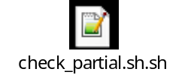
Path: /orvappl_mdg/CTVA/OperationScripts Operation (10.56.96.28)
Query: nohup ./check_partial.sh >> <file_name>.out
(Replace file_name with any name for output)

Open the newly created file to get output.
PROCESSING OF SINGLE FILES ADATPER
Files will be available in raorv@ 10.56.96.28 and raorvner @ 10.56.96.33 server on daily basis.
AIR_MDG_IPACS_CST_PACKAGE
AIR_MDG_IPACS_HBSM_CST_CUST_MAST
AIR_MDG_IPACS_INV_RC_CHARGES
AIR_MDG_IPACS_HBSM_TRF_PKG_MAST
AIR_MDG_IPACS_HSBT_CST_FB_FNF
AIR_MDG_IPACS_HBST_CUG_DETAILS
AIR_MDG_IPACS_JNL_ACCOUNTICTS_CODES
AIR_MDG_IPACS_ROAM_TEMP_TAPINS_HIST
AIR_MDG_IPACS_TAPIN_CHARGES
AIR_MDG_IPACS_TRF_RAT_UNALLOC_CAL
AIR_MDG_IPACS_TRF_TARRIF_PLAN
AIR_MDG_IPACS_CIN_M_SIM
AIR_MDG_IPACS_CST_PACKAGE_COMPONENT
AIR_MDG_IPACS_EQUIP_MASTER
AIR_MDG_IPACS_HBST_RAT_UNBILD_CAL
LOG LOCATION: /orvappl_mdg /CTVA/iCTVA_Scripts/Operation/

BACKUP Retention: for 30 Days

To Stop the Application for crontab:-
Open the cron and Comment all the script mentioned in Cron Section in Top of this Document

To Start the Application:
Server IP: 10.56.96.31
To Start Base:
1. Goto: /orvappl_mdg/CTVA/IRMS_DB2/connectiva-base/bin by typing command base
2. rm nohup.out
3. Run→nohup ./StartBase.sh &

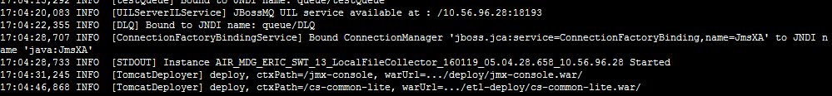

To Start RAS:
Server IP: 10.56.96.34
1. Goto: /orvappl_mdg/CTVA/IRMS_DB2/connectiva-ras/bin by typing ras
2. rm nohup.out
3. Run→nohup ./StartRas.sh &

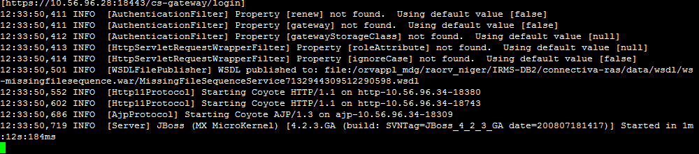

To Start ETL:
Server IP: 10.56.96.33
1. Open the cron and uncomment all the script mentioned in Cron Section in Top of this Document
2. Goto: /orvappl_mdg/CTVA/IRMS_DB2/connectiva-etl/bin by typing command etl
3. rm nohup.out
4. Run→ nohup ./StartEtl.sh &

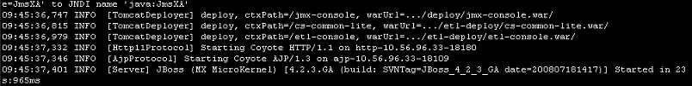

6. Check DB Loader is running:
. go to etl
. run tail –f nohup.out
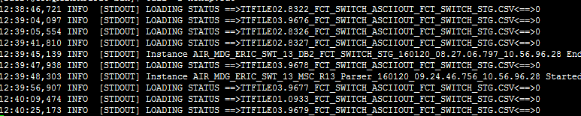

7. Reprocessing of Any Source:

1. Get the RAW files from backup location
2. Unzip all those files which need to reprocess.
3. Remove entry from odc_stat_input_resource/ odc_hist_stat_input_resource table
4. Copy all the files which need to reprocess into /poller_data/<source folder>.
5. It will automatically start reprocessing.
6. Check the loading status in orv5_etl.ODC_STAT_LOADING table.

8. Re-Loading of Any Source
1. Get the RAW files from backup location
2. Unzip all those files which need to reload (if zipped)
3. Remove entry from odc_stat_input_resource/ odc_hist_stat_input_resource table
4. Copy all the files which need to reprocess into /poller_data/<source folder>.
5. It will automatically start reprocessing.
6. Check the loading status in orv5_etl.ODC_STAT_LOADING table.
9. Log Information

ETInstance | /orvlog_mdg/CTVA/ETL_LOG/InstanceLog/ETInstance/
FeedInstance | /orvlog_mdg/CTVA/ETL_LOG/InstanceLog/FeedInstance/
LoadInstance | /orvlog_mdg/CTVA/ ETL_LOG/InstanceLog/LoadInstance/
ResourceLog | /orvlog_mdg/CTVA/ResourceLog
ServerLog | /orvlog_mdg/CTVA/ServerLog
FEED_LOG | /orvlog_mdg/CTVA/FEED_LOG

4.5. Weekly Jobs
- Need to Check the partition of fct Table

db2 "select TABNAME, max(DATAPARTITIONNAME), min(DATAPARTITIONNAME), count(1) from syscat.datapartitions where tabname in (select table_name from partitioned_tbl_list where table_name not like '%ERR') and tabschema='ORV5_ETL' and DATAPARTITIONNAME like 'DATE_2%' group by TABNAME order by 2 with ur"

Detach partition from database.

STEPs TO Detach and Drop PARTITIONs

Step 1: Shutdown all ETL servers.
Step 1: Please identify the table names and corresponding partition names from the “ETL_PURGE_STATUS” table and derive for FACT and DIM tables from the retention policy.
Step 2: Find out the latest partition that was present for FACT and DIM tables.
Step 3: As the script is automated so please run the scripts like below e.g .Kinldy run the script using date in the prefix.
e.g.
Location: /orvappl_mdg/CTVA/OperationScriptS/
nohup ./ Detach_N_Drop_All_generic.sh &
After successful execution of this script all the partitions before the partition name mentioned in the script will be detached and dropped.
Script is attached for your reference.
Step 4: After executing purging script successfully please run watermark script i.e high to low by DB2 –DBA team .This will be done by DB2-DBA team .Please raise this request to them for executing the watermark script for Madagascar DB to cut down the mount point space.
Step 5: Unhash the crontab and start all the ETL servers for this env.

We can detach and drop a single table using the below command
./Detach_N_Drop_Generic_Custom.sh ORV5_ETL DIM_CCN_DEDICATED_INFO_CS5 DATE_201508250000
If we want to drop any partition which is not present then the script will throw proper message
At the time of detach and drop the partitions all the transactions on these tables should be stopped
4.6. Monthly Jobs
- Partition Extend:

PARTITION DETAIL

Different tables are partitioned based on different columns.
All these detail we can get from the below query:
“select * from syscat.datapartitionexpression”
To know the existing partitions for a table you can use the below query:
“select * from syscat.datapartitions”
In our case all the tables are partitioned by range and based on date column. Though the number of partitions per day varies and depends upon the nature of the table.
STEPs TO PARTITION
Log in to db by using current password.
command | db2 connect to radb user orv5_etl using ‘*****'
command | update ORV5_ETL.partitioned_tbl_list set TO_B_PARTITIONED='Y'
command | db2 "call partition_management ('2015-11-01','2015-11-31')"

NOTE: Run before end of month for next month and do for complete month by calling partition_management procedure in 6 day chunks
To check whether partitions are created
command | db2 " select tabname,max(DATAPARTITIONNAME) DATAPARTITIONNAME,count(*) COUNT from syscat.datapartitions  where DATAPARTITIONNAME like 'DATE_20151106%' group by tabname ORDER BY 1 with ur"

NOTE: Partition_management procedure is embedded here.

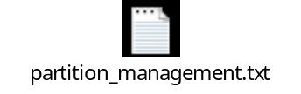

FAQ

All the tables which are present in the ORV5_ETL.PARTITIONED_TBL_LIST table will be partitioned
If any table contains the partition and we have re executed the procedure for the same period then partition will remain as it is
At the time of creating the partitions all the transactions on these tables should be stopped

All Settings Mentioned Are Based On Recommended Deployment Strategies and Minor Modification May Be Required During Execution.
SDR VALUE updating:
We need to request to client at the end of each month for SDR value of next month which need for TAP file processing. After getting the same from client need to update the DIM_RA_MAST_SDR table accordingly.
Query:
db2 "insert into DIM_RA_MAST_SDR values (1.40757, to_date('07/01/2015','MM/DD/YYYY'),'USD',sysdate,to_date('06/30/2015','MM/DD/YYYY'),'201506',4,3210.00330)";

Query for check the max and min partition for each table:
db2 "select TABNAME, max(DATAPARTITIONNAME), min(DATAPARTITIONNAME), count(1) from syscat.datapartitions where tabname in (select table_name from partitioned_tbl_list where table_name not like '%ERR') and tabschema='ORV5ETL' and DATAPARTITIONNAME like 'DATE_2%' group by TABNAME order by 2 with ur"

Status Table Clean-up:
As the sources running on ETL server, so there are only 1 sys schema also. We need to clean the status tables as weekly or fortnightly as requirement. We need to do the same for enhancement of processing performance.
STATUS TABLES:
ODC_STAT_LINK
ODC_STAT_TASK
ODC_STAT_DUPLICATE
ODC_STAT_POST_PROCESSING
ODC_STAT_LOADING
ODC_STAT_OUTPUT_RESOURCE
ODC_STAT_INPUT_RESOURCE
ODC_STAT_INSTANCE

Steps:
Server should be idle for the respective schema and sources.
Shutdown the server.
Take the backup of original tables (INPUT_RESOURCES and LOADING are mandatory). For good practice create new table with date stamp like ODC_YYYYMMDD_INPUT_RESOURCE
Truncate the tables.
Resume the processing.
Example Query to do DB Clean UP:

Step 1: Insert data into HIST table’s
db2 "insert into ORV5_SYS.ODC_HIST_STAT_LOADING select * from ORV5_SYS.ODC_STAT_LOADING"

db2 "insert into ORV5_SYS.ODC_HIST_STAT_OUTPUT_RESOURCE select * from ORV5_SYS.ODC_STAT_OUTPUT_RESOURCE"

db2 "insert into ORV5_SYS.ODC_HIST_STAT_INPUT_RESOURCE select * from ORV5_SYS.ODC_STAT_INPUT_RESOURCE"

db2 "insert into ORV5_SYS.ODC_HIST_STAT_INSTANCE select * from ORV5_SYS.ODC_STAT_INSTANCE"
Step 2: Truncate tables

db2 "delete from ORV5_SYS.ODC_STAT_LOADING"

db2 "commit";

db2 "delete from ORV5_SYS.ODC_STAT_OUTPUT_RESOURCE"

db2 "commit";

db2 "delete from ORV5_SYS.ODC_STAT_INPUT_RESOURCE"

db2 "commit";

db2 "delete from ORV5_SYS.ODC_STAT_INSTANCE"

db2 "commit";

db2 "delete from ORV5_SYS.ODC_STAT_LINK";

db2 "commit";

db2 "delete from ORV5_SYS.ODC_STAT_TASK";

db2 "commit";

db2 "delete from ORV5_SYS.ODC_STAT_POST_PROCESSING";

db2 "commit";

db2 "delete from ORV5_SYS.ODC_STAT_DUPLICATE";

db2 "commit";

Step 3: Delete 30+ age data from HIST tables.

db2 "delete from ORV5_SYS.ODC_HIST_STAT_LOADING where trunc(LOAD_START_TIME) <trunc(sysdate -30)";

db2 "commit";

db2 "delete from ORV5_SYS.ODC_HIST_STAT_OUTPUT_RESOURCE where trunc(START_TIME) <trunc(sysdate -30)";

db2 "commit";

db2 "delete from ORV5_SYS.ODC_HIST_STAT_INPUT_RESOURCE where trunc(PROCESS_START_TIME) <trunc(sysdate -30)";

db2 "commit";

db2 "delete from ORV5_SYS.ODC_HIST_STAT_INSTANCE where trunc(CREATE_TIME) <trunc(sysdate -30)";

db2 "commit";
NOTE: Above Task is automated no need to perform but in need above method can be performed

Automated script: /orvappl_mdg/CTVA/iCTVA_Scripts/Operation/cleanup_script_daily.sh

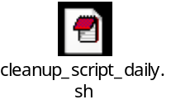
System Cleanup:
As retention policy we need to maintain the files, logs, table partition as below:
Backup Files | 30 Days
Logs | 10 Days
CSV (if any) | 3-4 days
FCT Partition | 31 Days

Some Other locations also need to clean manually as operation process. The paths are as below:
/orvappl_mdg/ICTVA/IRMS_DB2/connectiva-etl /work
/orvappl_mdg/ICTVA/connectiva-etl /data
/orvappl_mdg/ICTVA/connectiva-etl /tmp
/orvappl_mdg/ICTVA/connectiva-etl/log
/out_data_1/jobstore
/out_data_1/<source wise folders>
/orvlog_mdg/ICTVA/ETL_LOG
/poller_data/<source wise folders>
/back_data/<source wise folders>

4.7. Password Change Activity
STEPs for password change activity

To check last password reset and expiry date
chage -l <username>
Replace username with raorv or given username.
Step 1: Stop all the running servers (ETL, RAS & BASE).
- First stop RAS then ETL then BASE
NOTE: First stop all feed scripts
Step 2: Reset password on all server using passwd command (DB, ETL1, ETL2, RAS, RATING)
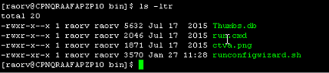
Step 3: Execute runconfigwizard.sh with the new DB passwords from both the ETL and RAS servers.
Location – ‘/orvappl_mdg/CTVA/IRMS-DB2/configwizard/bin’
Script name – ‘runconfigwizard.sh’
Step 4: Change passwords for scripts running in all ETL and RAS servers. Follow the below steps.
a. Go to the below mentioned path
/orvappl_mdg/CTVA/iCTVA_Scripts/GLOBAL_DB_CREDENTIAL/

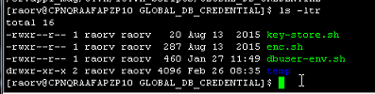
b. Use enc.sh to encrypt the password for each server separately as shown below.
./enc.sh <password>
c. Replace the new encrypted password with the existing password in script dbuser-env.sh.
d. The go to Path: /orvappl_mdg/CTVA/iCTVA_Scripts
Use enc.sh to encrypt the password for each server separately
Server IP: 10.56.96.28
Server IP: 10.56.96.33
./enc.sh <password>
Here paste the encrypted password in global-env.sh
e. Type script ::
./encrypt.sh < password >
vi unixenv and change pass.

Step 5: Change passwords of DB users used for GUI job scheduling using the software at below mentioned location in RAS server.
/orvappl_mdg/CTVA/OperationScripts/Scheduler_merge2fct_job_Db2/bin
Script name – ‘Run.sh’

Inputs to be provided while running this script
**************************************************************
Command Line Tool For Scheduler
**************************************************************
Enter Database IP:
10.56.96.31
Enter Database Port:
60000
Enter SID:
radb
Enter Database Type (ORACLE/DB2):
DB2
****************************************************************************
Enter SYS Schema Name:
ORV5_SYS
Enter SYS Schema Password:
<Password>
****************************************************************************
Enter ETL Schema Name:
ORV5_ETL
Enter ETL Schema Password:
<Password>
****************************************************************************
Enter RAS Server IP:
10.56.96.34
Enter JNDI Port:
11399
Enter DatasourceName:
datasource_etl
Update has been done successfully, please check in Scheduler GUI...
****************************************************************************
Password change for GUI:
1 Login to GUI

http://10.56.96.28:18180/etl-console
username= ADMIN
passpord= *******

2 Then go to user management tab.
3 Click on user.
4 Change the password.
Current password for UserName “” is “”

Appendix & Glossary of Terms

